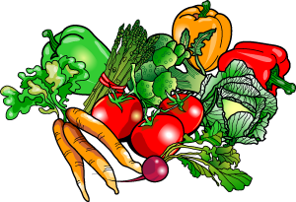
JUNIOR CERTIFICATE HOME ECONOMICS
FOOD & CULINARY SKILLS EXAMINATION 2018

Task No. 2 | Exam No.

Vegetarian diets are gaining in popularity as more and more people are becoming concerned about health and healthy eating. Name one type of vegetarian diet. Suggest some examples of sweet and savoury dishes that can be served as part of your chosen vegetarian diet. Demonstrate your culinary skills by preparing, cooking and serving one savoury dish and one sweet dish that you have researched.
Analysis of task:

Factors to consider:
Type of vegetarian name: ________________________________
Explanation:

Possible Solutions
Savoury Vegetarian Dishes | Sweet Vegetarian Dishes

My Solution
Savoury Dish: | Sweet Dish:

Reasons why I chose them:

 | Ingredients & Equipment Needed
 | Ingredients |  | Equipment
 | Amount |  | Serving Equipment:  Serving Equipment:
Time Plan
- Preparation (30 minutes):

- Exam (1 hour 30 minutes):

