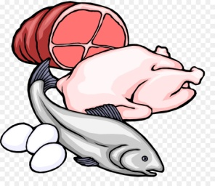
JUNIOR CERTIFICATE HOME ECONOMICS
FOOD & CULINARY SKILLS EXAMINATION 2018

Task No. 3 | Exam No.

Fish and chicken provide a very good source of HBV protein as part of a healthy diet. Design and set out a two course dinner menu which includes fresh fish / smoked fish or chicken as a key ingredient. Demonstrate your skills by preparing, cooking and serving the complete main course of the meal for at least two people. Prepare and serve the starter or dessert to complement the meal.

Analysis of task:

Factors to consider:
Starter/Dessert:

Why is HBV Protein needed in the body?

List sources of HBV protein:

Possible Solutions
Menu 1 | Menu 2
~~~~~ | ~~~~~

My Chosen Menu

Reasons why I chose this menu:
 | Ingredients & Equipment Needed
 | Ingredients |  | Equipment
 | Amount |  | Serving Equipment:  Serving Equipment:
Time Plan
- Preparation (30 minutes):

- Exam (1 hour 30 minutes):

